Fillable Form: either complete the form by clicking in each field with the mouse, then typing (the check/tick boxes need to be clicked with the mouse to be selected, or de-selected,) or print to complete manually. – thank you!
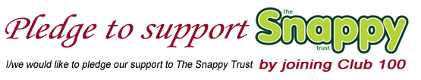
BUSINESS NAME:
LOCATION:
CONTACT NAME:
EMAIL ADDRESS:
Please choose one of the two options below:
ONGOING PLEDGE | I/we would like to pledge |  |  | £ |  | annually
 | & have set up a regular annual payment by standing order ☐
ANNUAL  PLEDGE  (We’ll contact you next year to ask if you’d like to continue) | I/we would like to pledge |  |  | £
 | For the duration of |  |  | year(s) |  | (min 1 year)
 | Payment made by: Bank Transfer: ☐ Cheque: ☐
BANK DETAILS | NAME: THE SNAPPY TRUST  SORT CODE: 05 02 00 NUMBER: 29911258 |  |  |  |  | CHEQUES PAYABLE TO: THE SNAPPY TRUST
☐ Please send a receipt |  |  | ☐ Please keep me/us up-to-date with Club100 news
☐ I/we would love to hear about other ways to help Snappy as they arise
Please complete and return to:

 |  | Post: | Snappy Club100, The Raylor Centre,
 |  |  | James St, York YO10 3DW
 |  | Email: | fundraising@thesnappytrust.org
We’ll be in touch shortly with your  welcome letter & Club100 certificate. |  |  | Thank you very much for your support! |  |  |  | DATE RECEIVED:
The Snappy Trust Charity Number: 702190 |  |  | Visit our website: TheSnappyTrust.org

